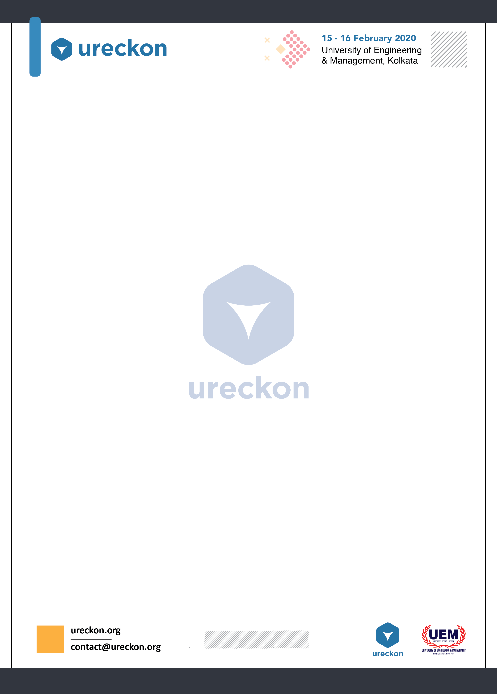**INTRODUCTION**

Now a days people are choosing junk food, fast foods and processed foods over healthy home cooked food thinking they taste well and cost less but never realizing the amount of harm they do because of daily consumption of the junk food to their own health. But little do people realize that healthy food can also taste good and can be cost effective also.

**WHAT IS HEALTHY BITES**

**Healthy Bites** is a cooking competition in which the participants get a competitive level to taste their cooking skills but with a little bit of twist. They will have to cook a healthy snack with one mandatory ingredient and without an ingredient which will be given in the **Rules and Regulations** section and brew up a healthy and tasty beverage to win the judges not just by taste but health factor too.

**RULES & REGULATIONS**

1. Teams have to prepare 1 snack and 1 beverage.
2. Teams also have to provide a printed approximate nutrition label with the amount of total calorie each item contains and list of ingredients used.
3. No outside food is allowed, for example - Commercial juices, Fruit concentrates. **(Soda can be used if required)**
4. Teams are requested to bring their cooking essentials and utensils on their own. Nothing will be provided.
5. Teams are requested to bring their own induction stove for cooking purpose.
6. **Mandatory ingredient: Bell Pepper or Capsicum( any kind)**
7. Teams will have to cook the dishes **without any kind of Oil.**
8. **Time Limit - 2 hrs. No extra time will be given.**
9. Maximum Team size - 4| Minimum Team Size - 2.

**JUDGEMENT CRITERIA**

Presentation - 10

Taste - 10

Health Factor- 30

**NOTE:** Breaking any of the rules will make you liable to be punished by the management team present on the venue under their discretion.

**DATE:- 11th January, 2020**